**Practical No. 26 and 27: Develop a program for implementation of throws clause.**

1. **Practical Significance:**

The throw clause is used to explicitly throw an exception from a method or any block of code. It is mainly used for throwing the custom exception. Students will be able to throw the user defined exception.

1. **Relevant Course Outcome:**

Implement Exception Handling.

1. **Practical Outcome:**

Develop a program for implementation of throw and throws clause.

1. **Minimum Theoretical Background:**

**Throwing Our Own Exceptions**

**throw:** All methods in java use the ‘throw’ statement explicitly to throw an exception form a method or any block of code The throw is a keyword in java. throw can be used for either checked or unchecked exception. It is mainly used to throw custom exceptions.

**Syntax:**

throw throwable-instance;

where Throwable-instance must be an object of type throw able or a subclass of Throwable.

**throws:** It is a keyword int java. It is used to declare an exception. It is used with a method signature. Multiple exceptions can be declared through throws.

**Syntax:**

type method name(parameters) throws exception list

1. **Program Code:**

class MyOwnException extends Exception

{

public MyOwnException(String msg)

{

super (msg);

}

}

class ThrowException2

{

static void employeeAge (int age) throws MyOwnException

{

if(age<18)

throw new MyOwnException("Not eligible for voting");

else

System.out.println("Eligible for voting");

}

public static void main (String[] args)

{

try

{

employeeAge(19);

}

catch (MyOwnException e)

{

System.out.println(e);

}

}

}

1. **Result:**

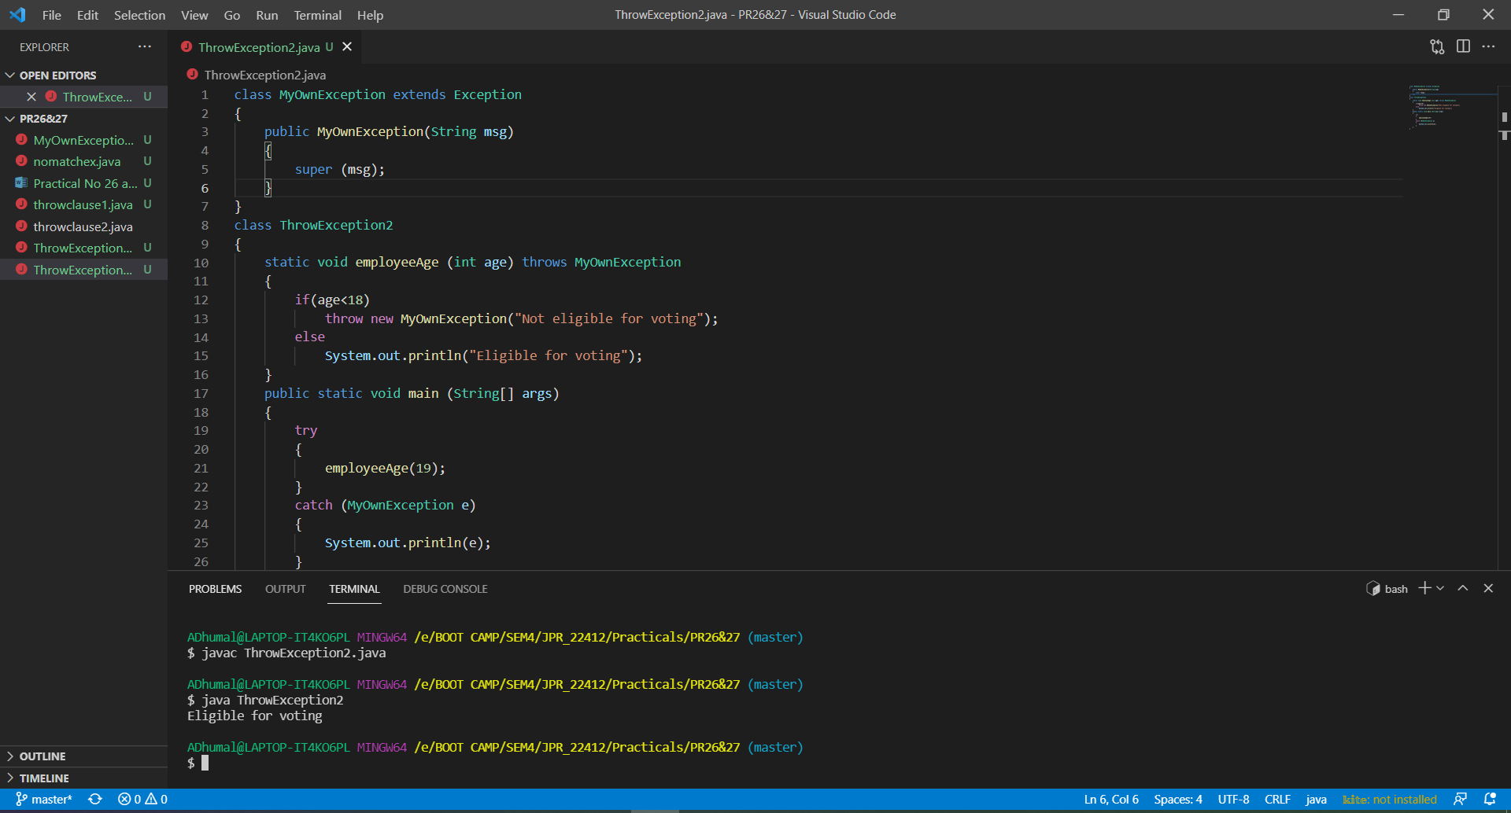

1. **Practical Related Questions:**
2. **Differentiate between throw and throws clause.?**

|  |  |  |
| --- | --- | --- |
| **Sr.**  **No.** | **Throw** | **Throws** |
| 1 | Throw keyword is used to throw an exception explicitly. | Throws keyword is used to declare an exception possible during its execution. |
| 2 | Throw keyword is followed by an instance of Throwable class or one of its sub-classes. | Throws keyword id followed by one or more Exception class names separated by commas. |
| 3 | Throw keyword is declared inside a method body. | Throws keyword is used with method signature. |
| 4 | We cannot multiple exception using throw keyword | We can declare multiple exception using throws keyword. |

1. **In which situation the throws clause is used?**

The Java throws keyword is used to declare an exception. It gives an information to the programmer that there may occur an exception so it is better for the programmer to provide the exception handling code so that normal flow can be maintained. Exception Handling is mainly used to handle the checked exceptions.

1. **Write a simple program for throwing our own exception?**

public class throwclause1

{

public static void main(String args[])

{

Thread.sleep(100000);

System.out.println("Welcome to Java Programming");

}

}

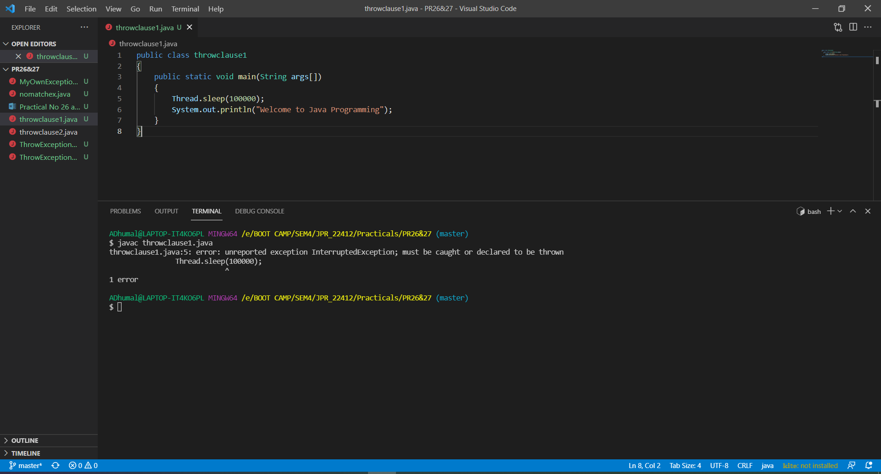

1. **Exercise:**
2. **Define an exception called “NotMatchException” that is thrown when a string is not equal to “India”. Write a program that uses this exception.**

public class nomatchexception

{

String s;

nomatchexception(String s)

{

this.s = s;

if (s.equals("India"))

{

System.out.println("Matched!\n");

}

else

{

throw new NoMatchException("Not Matched!\n");

}

}

}

class nomatchex

{

public static void main(String[] args)

{

nomatchexception v = new nomatchexception("America");

}

}

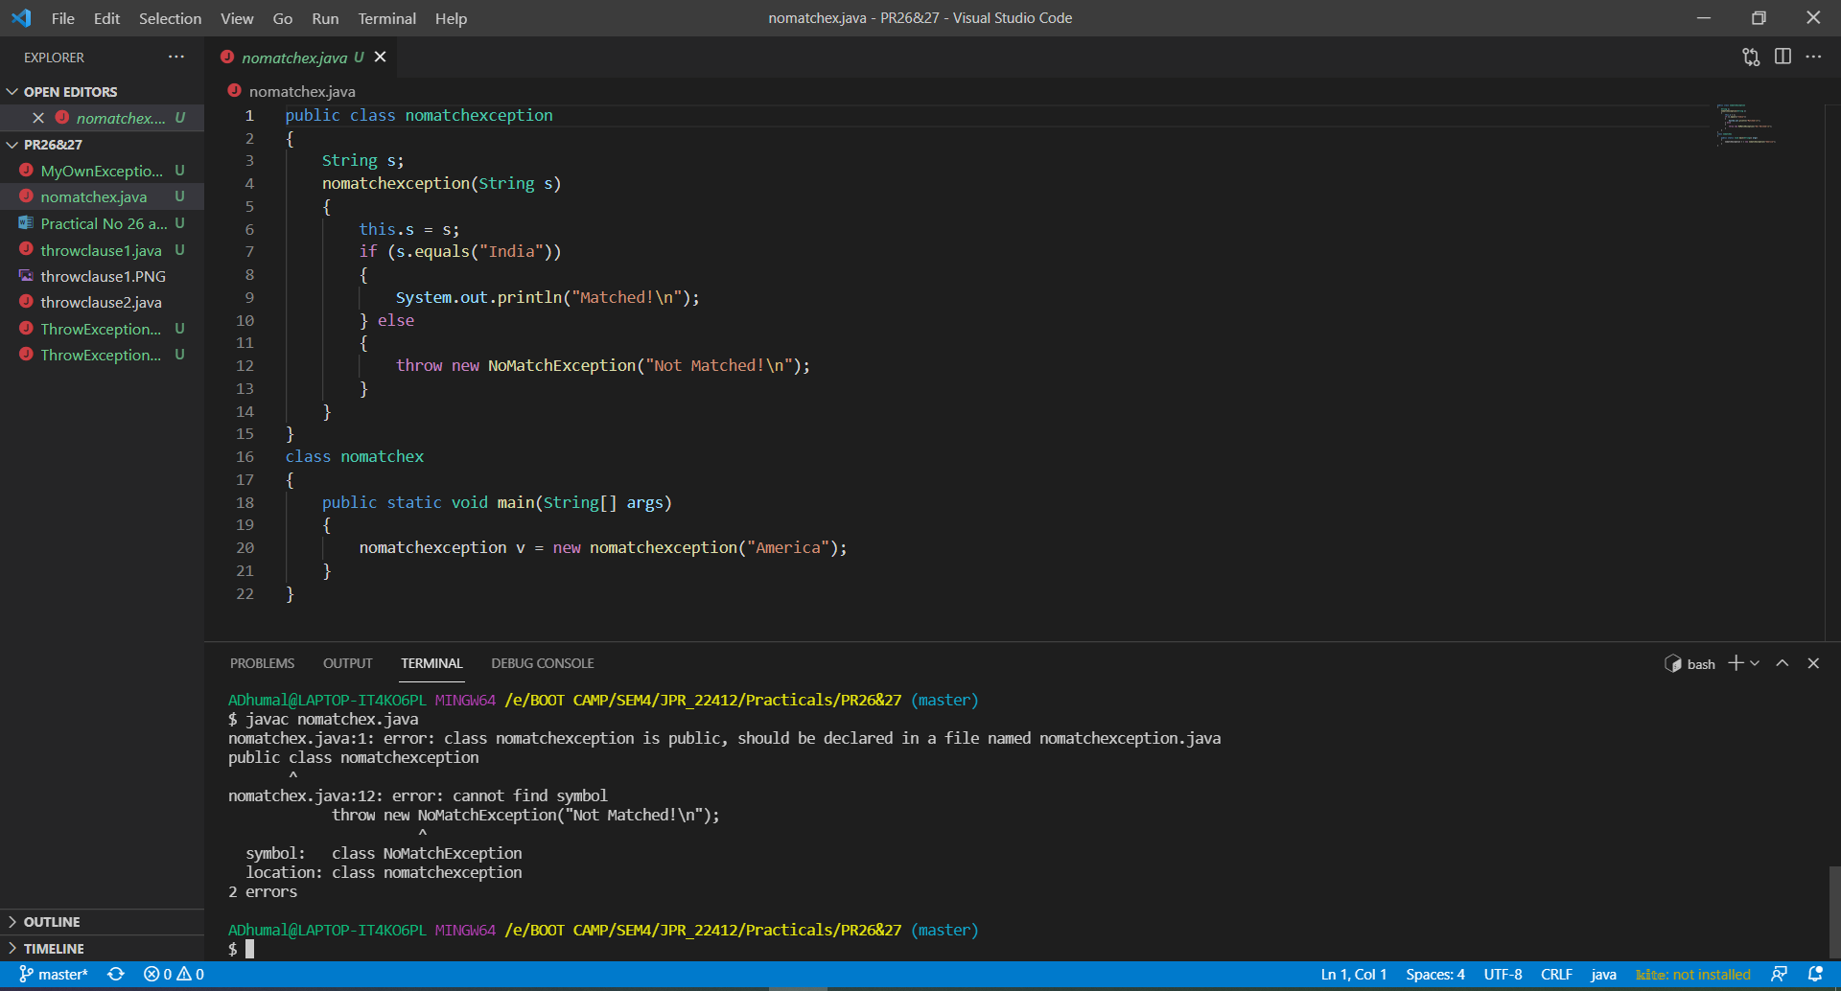

1. **Write the output of the following program.**

public class throwclause1

{

public static void main(String args[])

{

Thread.sleep(100000);

System.out.println("Hello Java");

}

}

1. **Write output of the following program.**

public class throwclause2

{

public static void main(String args[])throws InterruptedException

{

Thread.sleep(100000);

System.out.println("Hello java");

}

}

